**Photo Release 6 September 2024**

**Banpu Contributed THB 2,800,000 for Flood Recovery in Northern Thailand**

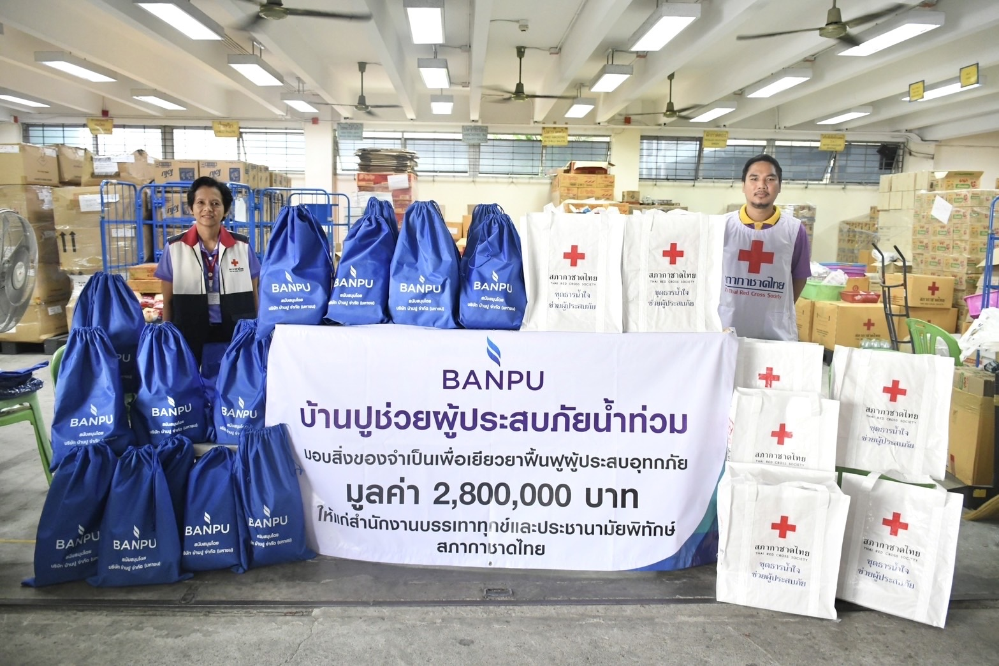

Recently, Banpu Public Company Limited contributed THB 2,800,000 to provide essential supplies and support for those affected by the flooding in northern Thailand. This aid, distributed through the Relief and Community Health Bureau of the Thai Red Cross Society, reached residents in six northern provinces: Chiangrai, Nan, Phayao, Phrae, Sukhothai, and Lamphun.

Banpu hopes this contribution will ease the impact of the disaster and support those affected in getting back to their normal life as quickly as possible.

# # #

**About Banpu**

Banpu Public Company Limited operates 3 core groups of businesses – energy resources, energy generation, and energy technology in Thailand, Indonesia, China, Australia, Lao PDR, Mongolia, Japan, the United States of America, and Vietnam.

**For more information, please contact Banpu Corporate Communications Team:**

Kamolwan Chiamudom 093-923-6355 [kamolwan_c@banpu.co.th](mailto:kamolwan_c@banpu.co.th)

Apinya Siramonpiwat 095-782-2369 [apinya_s@banpu.co.th](mailto:apinya_s@banpu.co.th)